Skill Tree List

Player Tree

Fast cool down time

Faster cool down time

Fastest cool down time

Earn Double Money

Earn Triple Money

Earn Double Exp

Earn Triple Exp

Unlock Special

2nd Special Storage

3rd Special Storage

Per Ship Stats

Attack/Defence/HP Bonus Part 1 // These are not 1 skill, its 3 different skills that boost

Attack/Defence/HP Bonus Part 2 // the stats that you buy

Change Your Ships Special // Ultimate skill!

Side not on how skill tree works

Stage 1, this is the start of the skill tree where the player has 1 skill unlocked and un-purchased.

Once the skill is bought they unlock stage 2 skills.

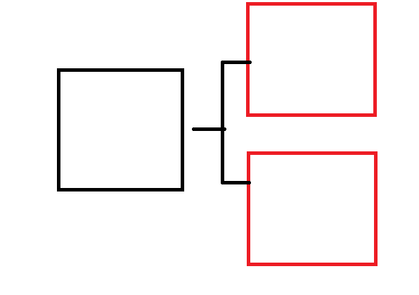

Stage 2, this stage works a little different from stage one, let’s say you were to buy skill A only, you would unlock Skill C, if you were to unlock Skill B only you would unlock Skill E only, if you buy both Skill A and Skill B than you unlock Skill C, D , E.

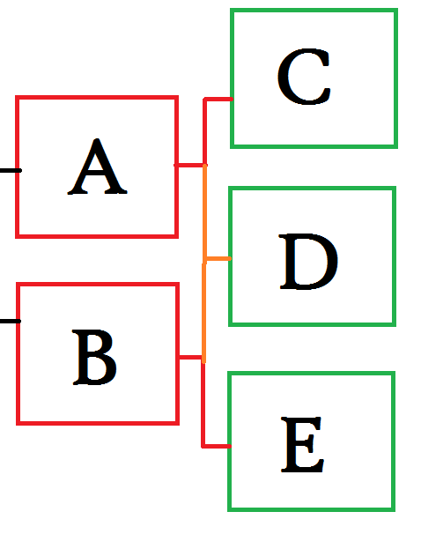

Stage 3, the final stage, in order to unlock the last skill you must have bought all previous skills. The last skill is the ultimate skill, so it has to be worth getting.

